**ICT Assignment 03:**

**Introduction:**

1. **Seaborn**: Seaborn is a Python data visualization library based on Matplotlib. It is used for creating visual plots with minimal code. It offers several built-in themes and color palettes to customize the look of the plots. Seaborn is commonly used for data analysis and communicating insights from data through visualizations.
2. **Tkinter**: Tkinter is a GUI library for Python. It provides tools for creating desktop applications with graphical user interfaces. Tkinter is easy to use and is the most widely used module for GUI applications in Python. With Tkinter, you can create windows, buttons, labels, textboxes, and other GUI elements to build interactive applications.
3. **Importance of GUI**: Graphical User Interfaces (GUIs) are essential as they make computers more accessible and easier to use, especially for those without technical expertise. They simplify interactions through visual elements like icons and windows, enabling quicker learning and more intuitive operation compared to text-based systems. GUIs also boost productivity by allowing multitasking and providing immediate visual feedback, helping users understand the consequences of their actions quickly. Furthermore, the consistency and standardization of GUI elements across various applications enhance the user experience and reduce the time needed to learn new software.

Now, regarding the inventory management system:

The inventory management system is developed using Python and Tkinter for the GUI. It allows users to manage their inventory efficiently by providing various functionalities:

1. **User Authentication**: Users can log in securely to access the system, ensuring that only authorized personnel can manage the inventory. Once a user is authorized only then he can use other functions of the inventory management system.
2. **Product Management**: Users can add, update, and delete products in the inventory database.
   1. Add new Product: They can enter details of product includes name, quantity, price, and category to add a new product.
   2. Update Product: Users need to specify the ID of the product that they want to update and new details of the product.
   3. Delete Product: Users give the ID of the Product that they want to delete from inventory Management System.
3. **Transaction Recording**: The system records real-time purchases, sales, and returns. It automatically updates stock quantities based on these transactions to maintain accurate inventory levels.
4. **Search**: Users can quickly find specific products using the search option based on product name.
5. **Sales Reporting**: The system generates a comprehensive Sales report that includes the details of top-selling Products and their Sales and summarizes the Total revenue generated.
6. **Low Stock Alerts**: The system alerts users about low-stock items (whose sale quantity is less than 10) in the inventory, enabling timely restocking and preventing stockouts.
7. **Database Backup and Restore**: Users can create backups of the inventory database and restore data.

**Task 1 Screenshots:**

**a)**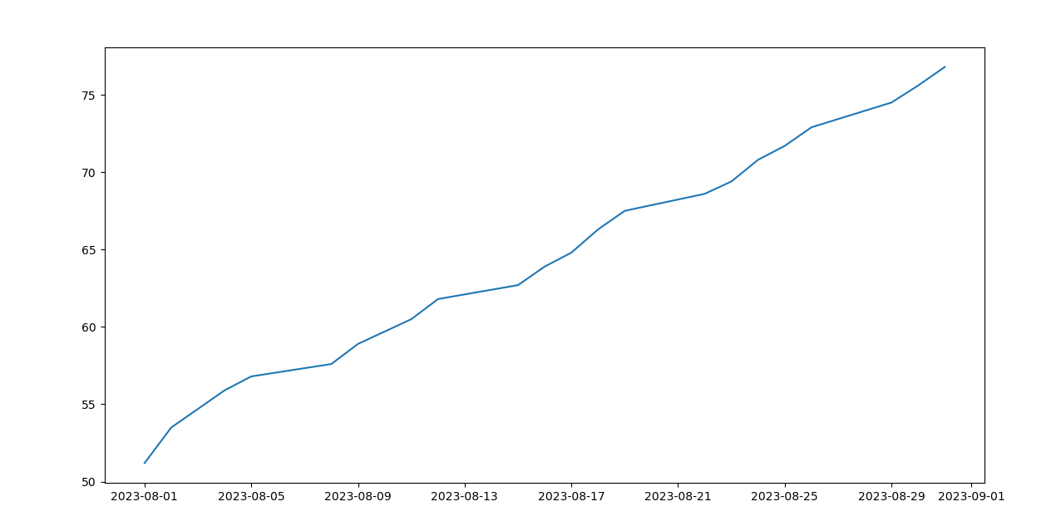

**Task 2 Screenshots:**

**a)**

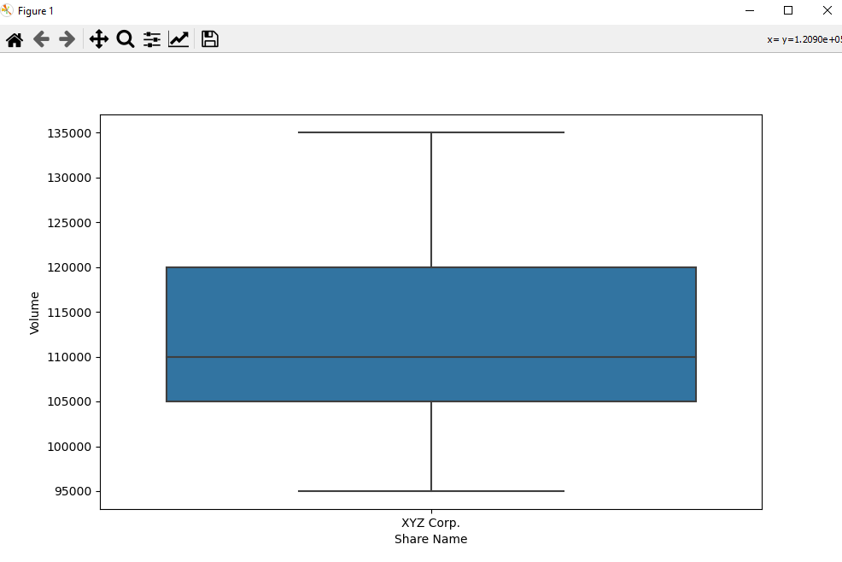

**b)**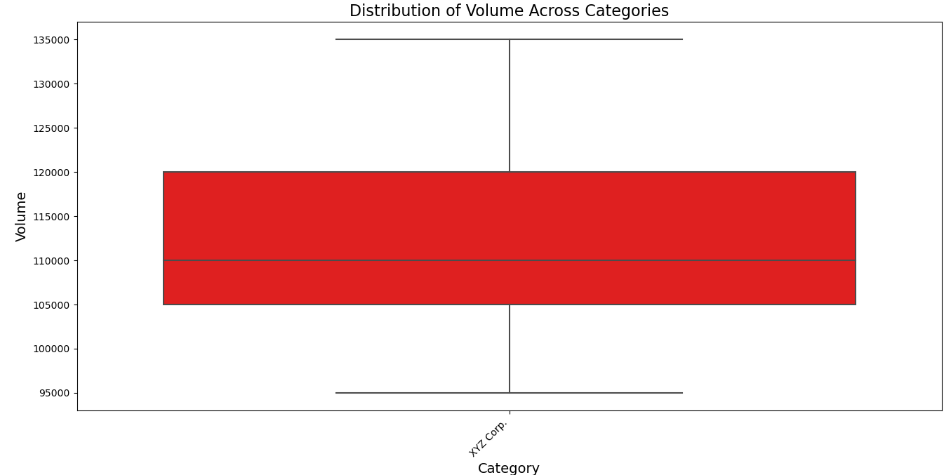

**Task 3 Screenshots:**

**a)**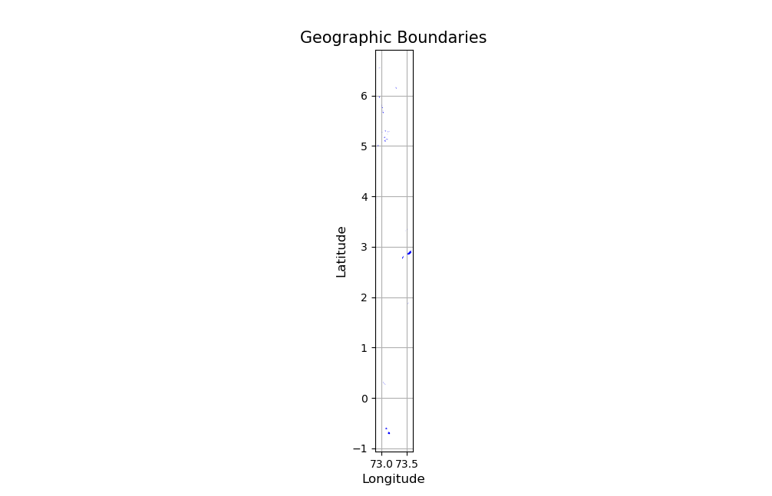

**Task 4 Screenshots:**

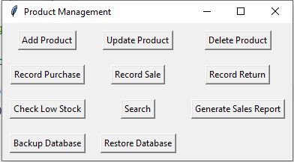

**1)**

**2)**

**3)**

**6)**

